Supplementary Materials for

Bio-inspired Superhelix Artificial Muscles Empowering Sensing-Actuation Integrated, Adjustable-Stiffness Soft Robotic Arms

Yongchang Zhang1, 2, 3, Guangyu Zhang1, Longqiu Li1, 4* *Member*, *IEEE,* Dekai Zhou1, 4*

1State Key Laboratory of Robotics and Systems, Harbin Institute of Technology, Harbin, 150001, China

2Department of Mechanical Engineering, Harbin Institute of Technology, Weihai, 264209, China

3Department of Control Science and Engineering, Harbin Institute of Technology, Harbin, 150001, China

4Zhengzhou Research Institute, Harbin Institute of Technology, Zhengzhou 450000, China

*E-mail: [dekaizhou@hit.edu.cn](mailto:dekaizhou@hit.edu.cn), [longqiuli@ hit.](mailto:longqiuli@hit.)edu.cn

**The PDF file includes:**

Sections S1 to S3

Figures S1 to S2

Legends for Supplementary videos S1 to S3

**Other Supplementary Materials for this manuscript include the following:**

Supplementary videos S1 to S2

**Section S1. The actuation mechanism of superhelix artificial muscles**

A. Theoretical calculation of output force

For a single constrained microtubule (as shown in Figure 1a), the force analysis is as follows.

In the axial direction:

 (1)

where *Ft* is the elastic force of the microtubule, *Fc* is the elastic force of the helical coil, and *Fp* is the actuation force based on fluid pressure.

According to reference [18, 19] in the main manuscript, *Ft*, *Fc*, and *Fp* are calculated as:

 (2)

where *α*, *E*, and *A*t are the stretch ratio, Young’s modulus, and real-time cross-sectional area of the microtubule, respectively, *x*t and *l*0 are the real-time and initial length of the microtubule, respectively.

 (3)

where kc is the stiffness coefficient of the micro-coil.

 (4)

Therefore, the external output force of a parallel fiber bundle containing multiple constrained flow tubes is:

 (5)

The output force of SAM proposed by the biomimetic collagen fiber structure is:

 (6)

**B. Comparison of Output Displacement between SAM and PAM**

From Fig. 2b, the following variables are defined:

and : Axial lengths of the SAM in the initial and actuated states, respectively.

and: Actual lengths of the PAM in the initial and actuated states, respectively.

and: Helical angles between the single fiber and the central axis in the initial and actuated states, respectively.

: Fiber elongation ratio, where .

By unfolding the helical structure into a right triangle, the axial length h is the projection of the actual fiber length l along the central axis. Thus,

 (7)

 (8)

To demonstrate the superior displacement of the SAM, we compare its displacement model with that of PAM.

The output displacement is defined as the actuated length minus the initial length:

 (9)

Substituting Eqs. (7) and (8) into Eq. (9):

 (10)

During actuation, the helical angle of the SAM decreases significantly, implying .

For the PAM, fibers are arranged parallel to the axis (). Consequently, output displacement depends primarily on the material's intrinsic elongation:

 (11)

Comparing the two displacement models:

 (12)

 (13)

Then,

 (14)

Since,

 (15)

So,

 (16)

Therefore, under unit actuation, the output displacement of SAM is greater than that of PAM.

**B. Comparison of Output Power between SAM and PAM**

We define the output work *W* as:

 (17)

We aim to prove that:

 (18)

For the PAM:

 (19)

 (20)

Thus,

 (21)

For the SAM:

 (22)

 (23)

 (24)

So we need to prove:

 (25)

That is

 (26)

 (27)

 (28)

 (29)

 (30)

Simultaneously divide Eq. 24 by , the final discriminant is

 (31)

From Formula 25, the right-hand term remains constant as a positive number.

Then, we attempt to introduce numerical proofs.

When , get 

Thus, provided the elongation ratio is less than 244%, the efficiency of the SAM exceeds that of the PAM.

**Section S2. Mechanism Analysis of Dual-helix Liquid Metal Sensor**

A. Basic Principles of Parallel Fiber Bundle Liquid Metal Resistive Sensors

For a resistive flexible sensor, the resistance value *R* is defined as:

 (32)

where  is the resistivity of the liquid metal, *L* is the path length of the sensor, and *A* is the cross-sectional area of the sensor.

Owing to the volume of the liquid metal being conserved during deformation (V is constant), the cross-sectional area is

*A*=*V*/*L* (33)

Substituting Eq. (33) into Eq. (32):

 (34)

This demonstrates that the resistance of the liquid metal flexible sensor is directly proportional to the square of the channel length.

For a single silicone tube liquid metal sensor or a parallel fiber bundle sensor, the axial strain is defined as:

 (35)

The extension ratio is

 (36)

Thus:

 (37)

The relative change in resistance for a single silicone tube or parallel fiber bundle sensor is:

 (38)

Eq. (38) indicates that sensitivity increases nonlinearly with strain, and the relationship between the rate of resistance change and strain is typically nonlinear.

Part II: Basic Principles of Dual-helix Liquid Metal Sensors

Based on Figure 3 in the main manuscript, the dual-helix sensor structure comprises two tubes winding upward around a central axis. For this helical structure, the external extension of the sensor does not directly equate to the elongation of the fluid channel due to "unwinding" and "necking" effects within the helix

Let the axial length of the sensor be and the helix diameter be D. Unfolding the helical tube into a right-angled triangle model, the initial unstretched state is described by:

Vertical side (Sensor Axis): 

Horizontal side (Circumferential Direction): 

where *N* is the number of helical turns, which remains constant during stretching.

The path length *L* of a single helical silicone tube satisfies:

 (39)

Using the geometric relationship 

 (40)

 (41)

The resistance change is derived as:

 (42)

However, the relationship between ΔR/R and deformation is not intuitively obvious from this formula alone.

In the double-helix structure, we introduce a cross-sectional squeezing effect to modify D. When the sensor undergoes large-scale stretching, it experiences not only axial elongation but also strong radial compression and contact pressure between the tubes. The cross-section of a single silicone tube becomes elliptical, with major and minor axes denoted as a and b, respectively. Typically, the reduction in b (radial thickness) occurs faster than standard free Poisson contraction.

For the tightly wound double-helix structure, the effective helix diameter D is primarily determined by the short axis b. Thus, D≈k *b* (where k is a geometric constant). Ideally, D=2*b*

Let the variation of b with extension be

 (43)

where  is the effective Poisson's ratio incorporating squeezing effects. For a silicone tube filled with liquid metal, assuming incompressibility, the ideal case is =0.5.

That is

 (44)

 (45)

Since , it follows that .

Differentiating Eq. (44)

 (46)

Substituting =0.5

 (47)

According to the "isotropic equilibrium condition" in flexible electronics, second-order nonlinear effects are minimized when the helical geometric ratio (tangential vs. radial) matches the material's Poisson's ratio. The mathematical condition is:

 (48)

Get

 (49)

Verification of optimal helix angle

We verify the sensor linearity at  using the best-fit straight line method. The resistance equation becomes:

 (50)

Calculating the maximum error based on the endpoint line method:

 (51)

The maximum deviation is:

 (52)

Calculating the slope using the endpoint line method:

 (53)

The experimentally measured fitting curve slope is 1.293. Therefore:

 (54)

This confirms a high degree of consistency between experimental results and theoretical predictions.

**Section S3. Kinematic modeling of the soft robotic arm based on superhelix artificial muscles**

The schematic diagram of the motion behavior of a soft robotic arm based on super spiral artificial muscles is shown in Figure 4a. We modeled forward kinematics (solving {x, y, z} based on given {l*i*1, l*i*2, l*i*3}) and inverse kinematics (solving {l*i*1, l*i*2, l*i*3} based on given {x, y, z}). The modeling process consists of two steps (Figure 4e): the first step involves transforming the coordinates of the end effector {x, y, z} and the length {l*i*1, l*i*2, l*i*3} coordinates of the super spiral artificial muscle. Intended to obtain inverse solutions from three input parameters {x, y, z} to four output parameters {l*i*1, l*i*2, l*i*3} without any other inputs. The second step involves converting between chamber length {l*i*1, l*i*2, l*i*3} and pressure {*pi*1, *pi*2, *pi*3}. Owing to the inherent nonlinear response of soft materials and the hysteresis phenomenon in hydraulic actuation, it is very difficult to achieve precise control of the robotic arm by adjusting the input pressure. Therefore, we established the quantitative relationship between {l*i*1, l*i*2, l*i*3} and {ΔR*i*1/R, ΔR*i*2/R, ΔR*i*3/R} (Figure 3f-j). Through monitoring the value of {ΔR*i*1/R, ΔR*i*2/R, ΔR*i*3/R}, to realize the real-time control of the increase or decrease of {*pi*1, *pi*2, *pi*3}.

To simplify the kinematic model, the following assumptions are proposed in this work:

(1) Each bending single-segment robotic arm has a constant curvature.

(2) The artificial muscles in the same segment of the robotic arm are parallel.

According to the kinematic modeling diagram in Figures 5c-e, the transformations from joint space (artificial muscles length {*l*11, *l*12, *l*13}) to configuration space (arc parameters {[*κ*](https://baike.baidu.com/item/%E5%B8%8C%E8%85%8A%E5%AD%97%E6%AF%8D/4428067#3-11)*i*, [*φ*](https://baike.baidu.com/item/%E5%B8%8C%E8%85%8A%E5%AD%97%E6%AF%8D/4428067#3-22)*i*, [*θ*](https://baike.baidu.com/item/%E5%B8%8C%E8%85%8A%E5%AD%97%E6%AF%8D/4428067#3-9)*i*}) is as follows:

 (55)

 (56)

 (57)

where r0 represents the distance from the axis of the superhelix artificial muscle to the axis of the robotic arm on the cross-section, *l*1j represents the length of the super spiral artificial muscle in the first bending segment, and [*κ*](https://baike.baidu.com/item/%E5%B8%8C%E8%85%8A%E5%AD%97%E6%AF%8D/4428067#3-11)1 is the curvature of the first segment of the robotic arm.

The three sections of the robotic arm are independently controlled. For each soft robotic arm, the above three formulas can be used to convert the configuration space (arc parameters{[*κ*](https://baike.baidu.com/item/%E5%B8%8C%E8%85%8A%E5%AD%97%E6%AF%8D/4428067#3-11)*i*, [*φ*](https://baike.baidu.com/item/%E5%B8%8C%E8%85%8A%E5%AD%97%E6%AF%8D/4428067#3-22)*i*, [*θ*](https://baike.baidu.com/item/%E5%B8%8C%E8%85%8A%E5%AD%97%E6%AF%8D/4428067#3-9)*i*}) to the task space (end coordinate parameters{x, y, z}).

In the bending segments, we describe the bending process in two stages: firstly, the bending segment rotates around the y-axis with [*θ*](https://baike.baidu.com/item/%E5%B8%8C%E8%85%8A%E5%AD%97%E6%AF%8D/4428067#3-9)*i*; secondly, the arm rotates around the z-axis with [*θ*](https://baike.baidu.com/item/%E5%B8%8C%E8%85%8A%E5%AD%97%E6%AF%8D/4428067#3-9)*i*. Furthermore, we need to post-multiply the homogeneous matrix with the rotation matrix R(–[φ](https://baike.baidu.com/item/%E5%B8%8C%E8%85%8A%E5%AD%97%E6%AF%8D/4428067#3-22)i) and zero translation. The transformation matrix from configuration space to task space for a bending segment is shown in

 (58)

The transformation of the entire soft robotic arm from joint space to task space is:

 (59)

Further, we conducted inverse kinematics analysis, that is, the transformation from task space to actuation space.

Firstly, we establish a transition relationship between the configuration space (arc parameters{[*κ*](https://baike.baidu.com/item/%E5%B8%8C%E8%85%8A%E5%AD%97%E6%AF%8D/4428067#3-11)*i*, [*φ*](https://baike.baidu.com/item/%E5%B8%8C%E8%85%8A%E5%AD%97%E6%AF%8D/4428067#3-22)*i*, [*θ*](https://baike.baidu.com/item/%E5%B8%8C%E8%85%8A%E5%AD%97%E6%AF%8D/4428067#3-9)*i*}) and the task space (end coordinate parameters{x, y, z}). Note that the arc parameters of each segment here are relative values to the previous segment of the robotic arm.

For example, in the first segment：

 (60)

 (61)

 (62)

Based on the above formulas, a conversion relationship can be established between the configuration space and the task space. Note that the arc parameters of each segment are relative values to the previous segment of the robotic arm.

 (63)

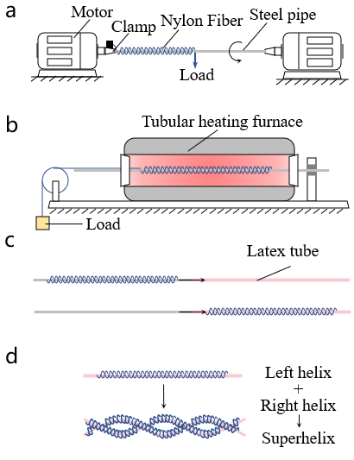

**Fig. S1. The manufacturing process of superhelix artificial muscles.** a. Wrap a constraint wire on a steel pipe; b. Release internal stress of constraint wires through annealing; c. Transfer the constraint wire to a latex tube; d. Transform multiple constrained left-handed microfluidic tubes into a superhelix artificial muscle through a right helix.

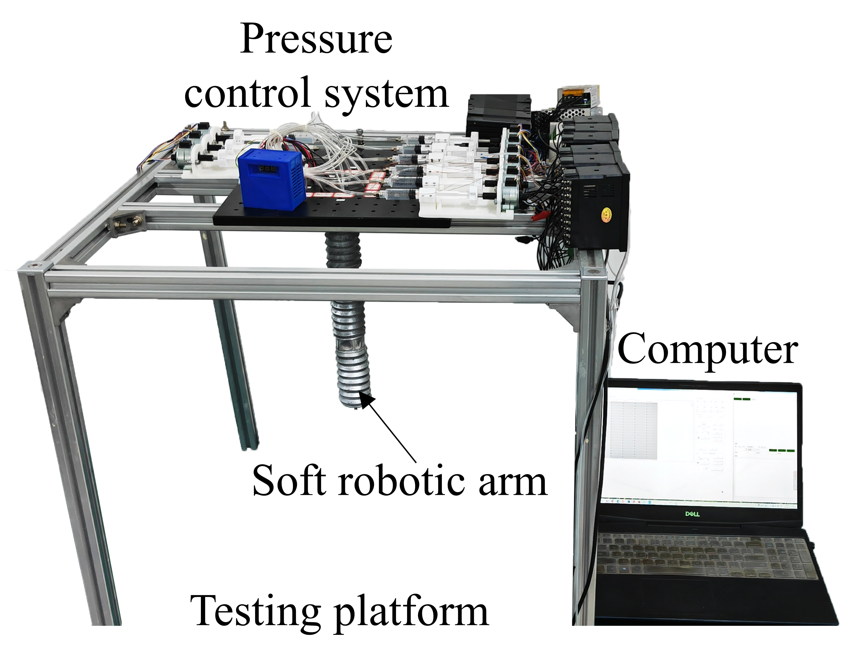

**Fig. S2. The experimental testing setup of the robotic arm system.**

**Supplementary Movie S1: Inspection of complex internal structures of wing models using the soft robotic arm**

**Supplementary Movie S2: Experiments of complex, special-shaped object handling based on the soft robotic arm**

**Supplementary Movie S3: Capture experiments of complex moving targets using the soft robotic arm equipped with a flexible gripper**